
DepartmentofCOMPUTERSCEINCEANDENGINERRING
MID-IIQUESTIONPAPER–MARCH-2025
Calculatorsarestrictlyprohibited
Year/SEM:III/II | Programme:B.Tech | CourseCode:UR20MC600  Date:
CourseName:ES-II | Total Marks:30 | Time:90min
CO:CourseOutcome Level:Bloom’sTaxonomy(Level1-6)

Answerallquestions (30X1=30M)
MARKS | Q.NO | Question
1 M | 1 | Whichdayfalls on10 thmay 1988 ?
1 M | 2 | From a pack of 52 cards one card is drown at random ., what is theprobabilitythatthe card is aten , a spade ?
1 M | 3 | Findthesurface area ofa20mX5mX3mofbrick?
1 M | 4 | If the radiusofthe circle isdimensionedby10%,thenitsarea dimensionedby ?
1 M | 5 | TodayisSundaywhat was66daysafter?
1 M | 6 | A sum ofmoney at the simple interestamount toRs: 815 in 3 years and to Rs 854 in 4 years , then the sum is ?
1 M | 7 | Ina 300 mtrace Abeats byB by22.5mt or6sec,Btimeover thecourse is ?
1 M | 8 | If thevolumeofasphere isdivided by itssurfaces area , theresult is 27cm , the radius of thesphere is ?
1 M | 9 | in how many different ways can be the letters of theword MATHEMATICS be arranged , so that thevowels always come together?
1 M | 10 | The diagonal of rectangleis 41Cmanditsareais20cm,theperimeterofthe rectanglemust be ?
1 M | 11 | How manywords , with orwith out meaning , can be formedby usingall the letters oftheword DELHI using eachletter exactly once ?
1 M | 12 | Whatistheanglebetweenthehandswhenshowingtimeat 8o clock?
1 M | 13 | Thevolumeoftwosphereareintheratioof64:27theratiooftheirsurface areas is ?
1 M | 14 | Reenatook a loanof Rs:1200 withsimpleinterest foras manyyears as therate of interest , ifshe paid Rs: 432 as interest attheend of the loan period, what was therate of interest ?
1 M | 15 | Oncardisdrownatrandomfromapackof52cardswhatistheprobability that the card drown is black card ?
1 M | 16 | What will be the area of semi circle of 14m of diameter ?
1 M | 17 | If theareaof anequilateraltriangleis243sqcmthenitsperimeteris?
1 M | 18 | 1 hour 15 minutes , what is the angle between the spikes?
1 M | 19 | Whatistherelativespeedofbigandsmall thorn?
1 M | 20 | The height of an equilateral triangle is 10 cm , its area is ?
Question(21to23)Studythegraphcarefullyandanswerthequestionsgiven below it ?
1. A person spends his time on different activities daily (in hours):
Activity | Office Work | Exercise | Travelling | Watching shows | Sleeping | Miscellaneous
No of hours | 9 | 1 | 2 | 3 | 7 | 2

1M | 21 | calculate the central angles of Sleeping
1M | 22 | calculate the central angles Miscellaneous
1M | 23 | calculate the central anglesOffice Work
1M |  | Question(24to27)Studythegraphcarefullyandanswerthequestionsgiven below it ?  Study the following bar chart and answer the questions carefully.  Sales Turnover of 5 Companies (in Rs. crores)  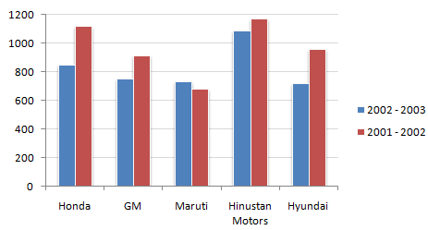
1M | 24 | What is the percentage change in the sales turnover of Hindustan motors
1M | 25 | Which of the companies shows the maximum percentage difference in sales between the two years ?
1M | 26 | Difference between honda in two years?
1 M | 27 | Scale of y axis ?
Question (28 to 30)Study the graphcarefully andanswer the questions given belowit?Thislinegraph showsratiooftheamountofimportsbyacompanyto amount

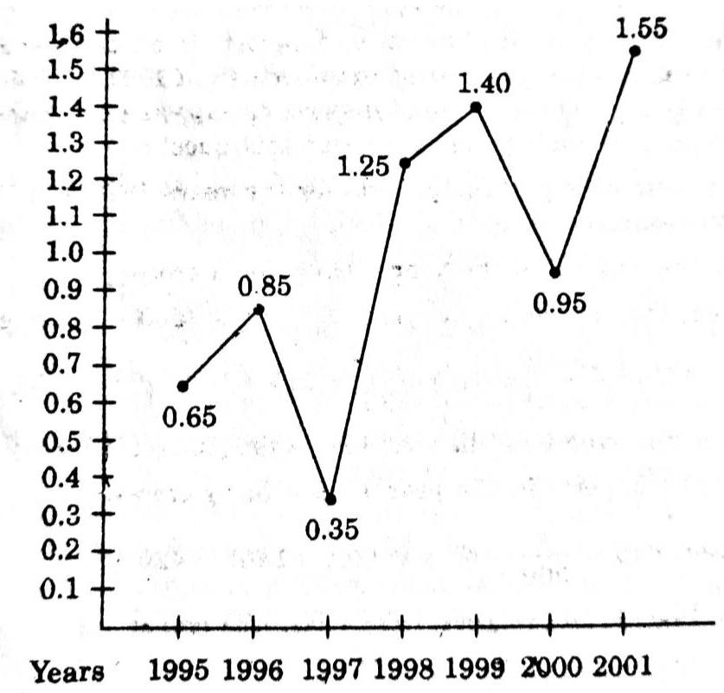

1 M | 28 | Whatwasthepercentageincreasesinimportsfrom1997to 1998?
1M | 29 | Howmanyof thegiven yearswere down,mentiontheyears?
1 M | 30 | Whatisthe differencebetween1997and2001

Question(21to23)
